Lab – Password Cracking
Additional Note: Yellow highlighted text indicates all of my answers.
(672021159)
Objectives
Use a password cracking tool to recover a user’s password.

Background / Scenario
There are four user accounts, Alice, Bob, Eve, and Eric, on a Linux system. You will recover these passwords using John the Ripper, an open source password cracking tool.

Required Resources
- PC with Ubuntu 16.04 Desktop LTS installed in a VirtualBox or VMware virtual machine.
- 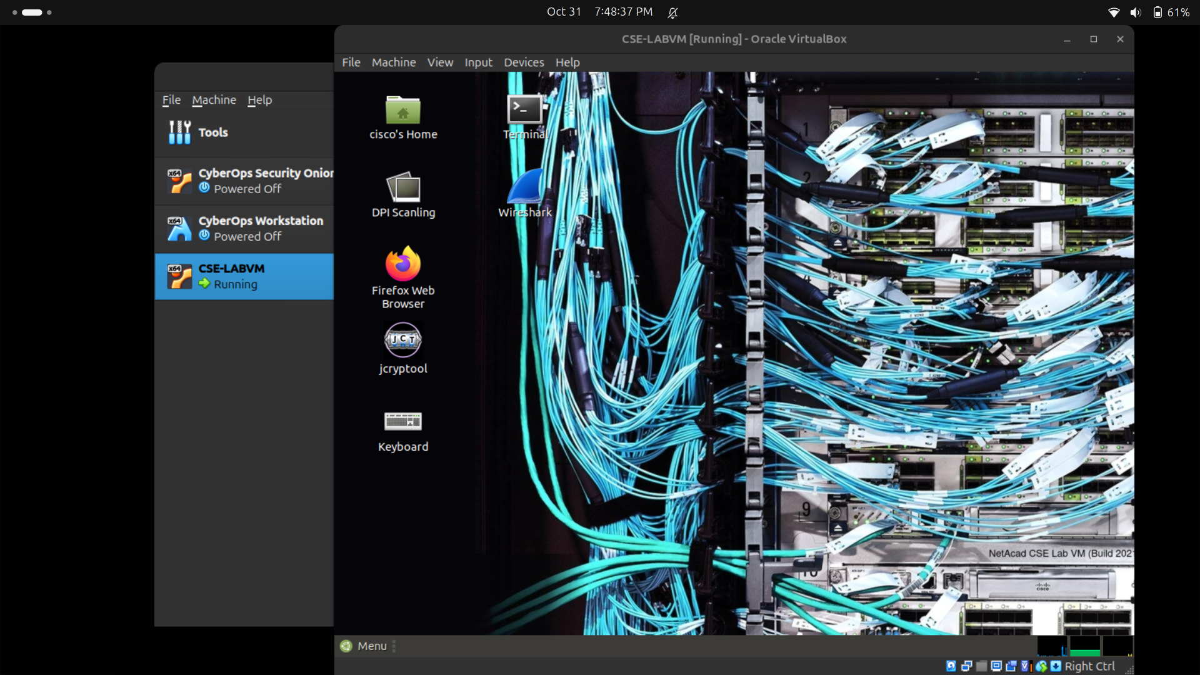
  - Open a terminal window in Ubuntu.
    - Log in to Ubuntu using the following credentials:
User: cisco
Password: password
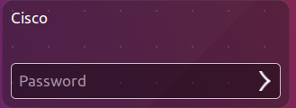
    - Click on the terminal icon to open terminal.
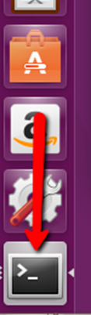
  - Run John the Ripper.
    - At the command prompt, enter the following command to change to the directory where John the Ripper is located:
cisco@ubuntu:~$ cd ~/Downloads/john-1.8.0/run
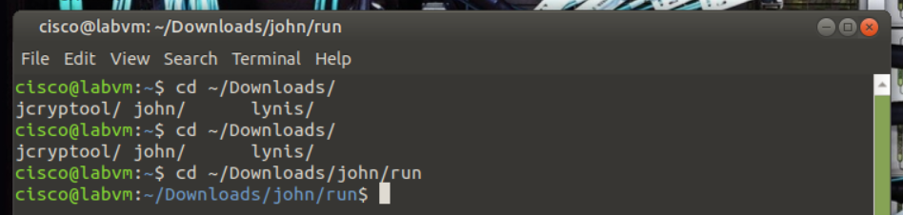
    - At the command prompt, enter the following command :
cisco@ubuntu:~/Downloads/john-1.8.0/run$ sudo ./unshadow /etc/passwd /etc/shadow > mypasswd
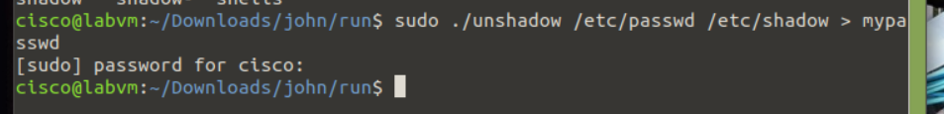
This command will combine the /etc/passwd file where user accounts are stored, with the /etc/shadow file where user passwords are stored, into a new file called “mypasswd”.
  - Recover Passwords.
    - Type the following command in terminal:
cisco@ubuntu:~/Downloads/john-1.8.0/run$ ./john --show mypasswd
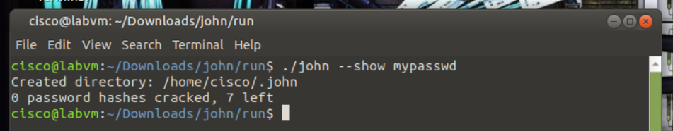
As shown above, there are no cracked passwords at this point.
    - At the command prompt, enter the following command:
cisco@ubuntu:~/Downloads/john-1.8.0/run$ ./john --wordlist=password.lst --rules mypasswd --format=crypt
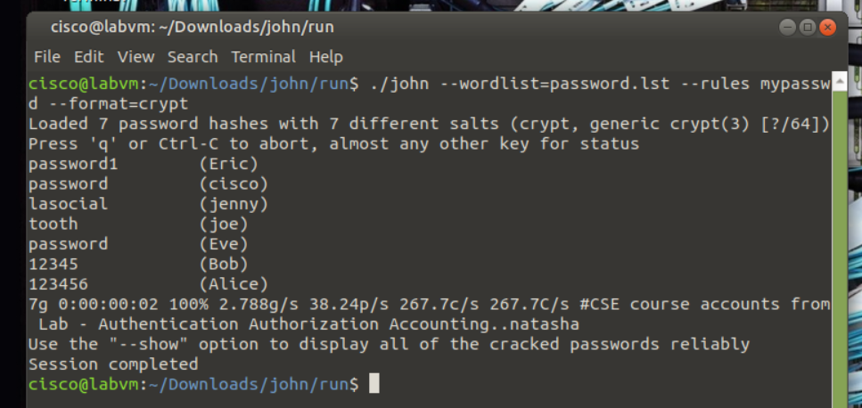
The program, John the Ripper, uses a predefined dictionary called password.lst with a standard set of predefined “rules” for handling the dictionary and retrieves all password hashes of both md5crypt and crypt type.
The results below display the passwords for each account.
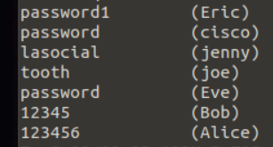
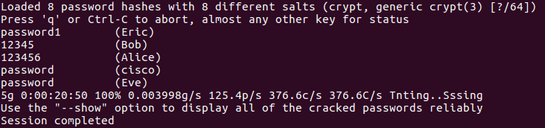
    - At the command prompt, enter the following command:
cisco@ubuntu:~/Downloads/john-1.8.0/run$ ./john --show mypasswd
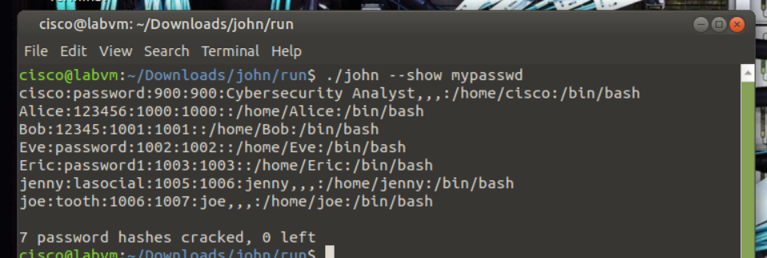
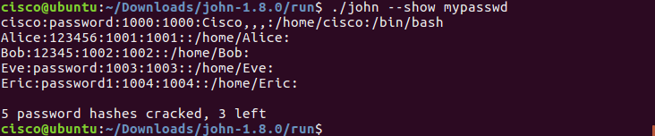
How many passwords were cracked?
A total of 7 passwords were cracked: 6 belong to user accounts, and 1 belongs to the system account (cisco).
____________________________________________________________________________________
References
John the Ripper: http://www.openwall.com/john/

